TECHNICAL DOCUMENT
Monitoring Stack – Prometheus + Grafana
Deployment, Operations & Scaling Guide for Infrastructure Monitoring

Author: Nguyen Tieu Phung – Technical Author
Version: 3.0
Deploy Server: 10.0.X.A | Monitored: 10.0.X.A, B, C, D

Table of Contents
1. System Overview 1
1.1 Core Components 1
1.2 Architecture Diagram 1
1.3 Data Flow – How node-exporter and cAdvisor Work 1
2. Deploying the Monitoring Stack (Deploy Server) 1
2.1 Copy project to the deploy server 1
2.2 Configure environment variables (.env) 1
2.3 Start all services 1
3. Deploying Exporters on Target Servers 1
3.1 Copy the exporter compose file to the target server 1
3.2 Start exporters on the target server 1
4. Adding a New Server (No Prometheus Restart Required) 1
Step 1 – Deploy exporters on the new server 1
Step 2 – Update Prometheus discovery files 1
Step 3 – Reload Prometheus 1
5. Spring Boot Integration (Java Microservice) 1
5.1 Add dependencies to pom.xml 1
5.2 Configure application.yml 1
6. Firewall / Security Group Configuration 1
7. Email Alert Configuration (Grafana + AWS SES) 1
7.1 Configure SMTP variables in .env 1
7.2 Apply configuration and test 1
8. Grafana – Dashboards & Access 1
8.1 Access information 1
8.2 Pre-installed dashboards 1
9. Useful Commands 1
9.1 View logs 1
9.2 Reload Prometheus 1
9.3 Manually verify metrics endpoints 1
9.4 Restart a single service 1

1. System Overview
This document describes how to deploy and operate the infrastructure monitoring stack using Prometheus and Grafana. The system is designed to collect metrics from multiple servers, display them on intuitive dashboards, and send automated alerts via email.

1.1 Core Components
- Prometheus (:9090) – Time-series metrics collector and storage engine. Automatically scrapes data from exporters on a configurable schedule.
- Grafana (:3000) – Metrics visualization tool with rich dashboards. Supports alerting rules and notification delivery.
- node-exporter (:9100) – OS-level metrics agent (CPU, RAM, disk, network) running on each server.
- cAdvisor (:8090) – Docker container resource metrics agent (CPU, memory, I/O) running on each server.
- Spring Boot Actuator (:8081/actuator/prometheus) – Built-in endpoint in the Java application that exposes application metrics.

1.2 Architecture Diagram
The diagram below illustrates the data flow between components. The deploy server (10.0.X.A) runs the full monitoring stack, while Prometheus periodically pulls metrics from target servers (B, C, D).

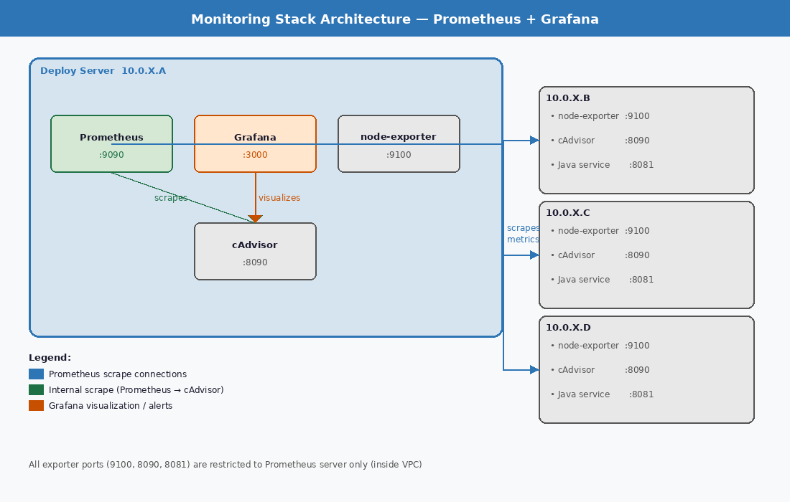
Figure 1: Monitoring Stack Architecture

1.3 Data Flow – How node-exporter and cAdvisor Work
A common point of confusion: where do node-exporter and cAdvisor collect data from, where is it stored, and how does it get "pushed" to Grafana? In fact, the opposite is true — this system uses a PULL model. No component actively pushes data anywhere.

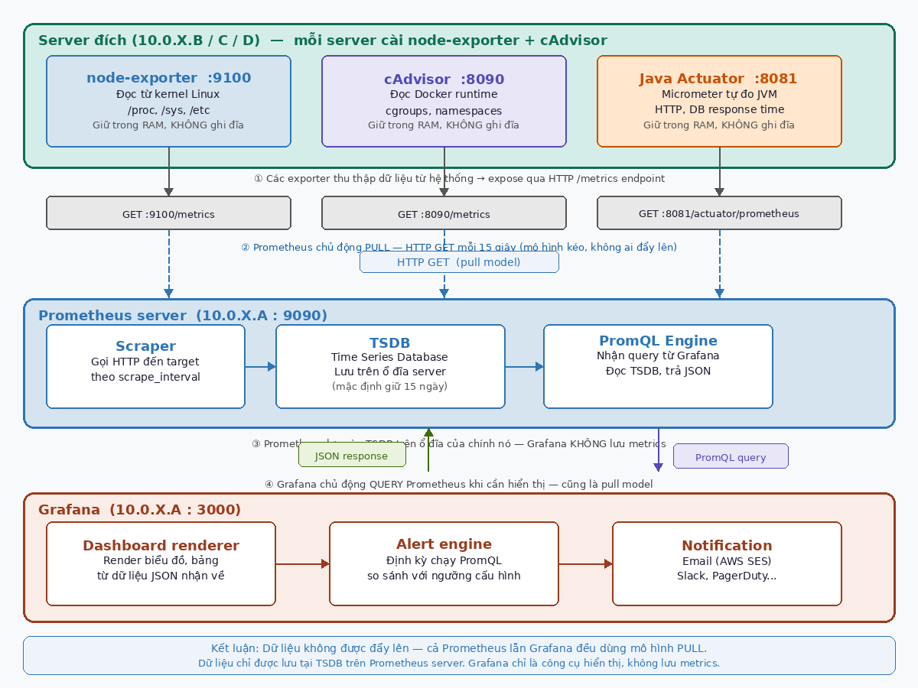
Figure 2: Data Flow – PULL Model
① Data Collection – node-exporter and cAdvisor read from the system
Exporters do not actively write logs or save files. They read data directly from the system and hold it in memory (RAM):
- node-exporter reads virtual files exposed by the Linux kernel: /proc/meminfo (RAM), /proc/stat (CPU), /sys/class/net/... (network). The kernel exposes this information natively — node-exporter simply reads and reformats it.
- cAdvisor reads the Docker runtime via Linux cgroups and namespaces — the kernel mechanism for container resource isolation — to obtain per-container CPU, memory, and I/O usage.
- Java Actuator uses the Micrometer library to automatically instrument JVM heap, thread pools, HTTP latency, and database connections from within the application.
ℹ️ Exporters do NOT write files to disk. Data exists only in RAM and is returned on demand when an HTTP request is received.

② Expose via HTTP /metrics – Prometheus plaintext format
Each exporter opens an HTTP endpoint that returns metrics in Prometheus plaintext format. Any client that sends an HTTP GET to that endpoint receives a real-time snapshot of the current data:
# Example response from node-exporter :9100/metrics
node_memory_MemFree_bytes 1.2e+09
node_cpu_seconds_total{cpu="0",mode="idle"} 12345.67
node_filesystem_avail_bytes{mountpoint="/"} 5.0e+10

③ Prometheus PULL – periodic scrape, stored in TSDB
Prometheus does not receive pushed data. Instead, it actively sends HTTP GET requests to each exporter endpoint on a configurable interval (default: 15 seconds). This is the PULL model — a key distinction from many other monitoring systems.
Scraped data is stored in the TSDB (Time Series Database) on Prometheus server's own disk (10.0.X.A). The default retention period is 15 days and can be adjusted as needed.
ℹ️ Data is stored in exactly one place: the TSDB on the Prometheus server. Grafana, exporters, and target servers do not store any metrics.

④ Grafana QUERY – pulls data from Prometheus on demand
Grafana also uses the pull model. When a dashboard is opened or the alert engine runs on schedule, Grafana sends a PromQL query via HTTP API to Prometheus. Prometheus reads from the TSDB and returns JSON. Grafana renders that JSON as charts and panels.
Grafana stores no metrics whatsoever — it is purely a visualization layer. If Grafana goes down, Prometheus continues scraping and storing data normally.

Summary: Who stores data and where?

Component | Data Source | Storage Location | Endpoint
node-exporter | Linux kernel: /proc, /sys | RAM – returned on request | :9100/metrics
cAdvisor | Docker cgroups / namespaces | RAM – returned on request | :8090/metrics
Java Actuator | Micrometer: JVM, HTTP, DB | RAM – returned on request | :8081/actuator/prometheus
Prometheus TSDB | Scrapes from exporters | Disk on Prometheus server (default 15d) | —
Grafana | Does not store — queries Prometheus | No metrics stored | —

2. Deploying the Monitoring Stack (Deploy Server)
This section guides you through installing the full monitoring stack — Prometheus, Grafana, node-exporter, and cAdvisor — on the deploy server (10.0.X.A) using Docker Compose.

2.1 Copy project to the deploy server
From your local machine, copy the entire project directory to the deploy server using scp. Then connect via SSH and navigate into the project folder.
scp -r monitoring/ user@10.0.X.A:~/
ssh user@10.0.X.A
cd ~/monitoring

2.2 Configure environment variables (.env)
The .env file holds all sensitive values such as Grafana admin password and SMTP credentials. Never hardcode these values directly in docker-compose.yml.
cp .env.example .env
nano .env # Fill in actual values
ℹ️ Keep the .env file secret. Do not commit it to your git repository.

2.3 Start all services
Once .env is configured, start the full stack with Docker Compose. The -d flag runs containers in detached (background) mode.
docker-compose up -d
docker-compose ps

3. Deploying Exporters on Target Servers
Each monitored server (10.0.X.B, C, D) needs node-exporter and cAdvisor installed. These are lightweight Docker containers whose sole purpose is to expose metrics for Prometheus to scrape.

3.1 Copy the exporter compose file to the target server
scp exporters/docker-compose.yml user@10.0.X.B:~/monitoring-exporters/docker-compose.yml

3.2 Start exporters on the target server
SSH into each target server, navigate to the folder, and start the exporters. Then verify that the metrics endpoints are responding correctly.
ssh user@10.0.X.B
cd ~/monitoring-exporters
docker compose up -d
docker compose ps
curl http://localhost:9100/metrics | head -5
curl http://localhost:8090/metrics | head -5
ℹ️ Repeat steps 3.1 and 3.2 for all remaining target servers (10.0.X.C and 10.0.X.D).

4. Adding a New Server (No Prometheus Restart Required)
Prometheus supports file-based service discovery, allowing new servers to be added without restarting. Prometheus automatically detects changes to discovery files within approximately 30 seconds.

Step 1 – Deploy exporters on the new server
Follow Section 3 to install node-exporter and cAdvisor on the new target server.

Step 2 – Update Prometheus discovery files
SSH into the deploy server and edit the YAML files under prometheus/targets/. Add the new server's IP address as shown below.
Update prometheus/targets/node_exporter.yml:
- targets: ["10.0.X.N:9100"]
labels:
hostname: "10.0.X.N"
server_role: "app"
env: "production"
Apply the same pattern to prometheus/targets/cadvisor.yml using port 8090.

Step 3 – Reload Prometheus
Prometheus will auto-reload within ~30 seconds. To apply changes immediately, send an HTTP POST to the reload endpoint without restarting the container.
curl -X POST http://10.0.X.A:9090/-/reload
ℹ️ Open http://10.0.X.A:9090/targets in your browser to confirm the new server appears with status UP.

5. Spring Boot Integration (Java Microservice)
To enable Prometheus scraping of a Java application, add the Micrometer and Spring Boot Actuator libraries to the project, then configure the /actuator/prometheus endpoint.

5.1 Add dependencies to pom.xml
Add the following two dependencies to the Spring Boot project's pom.xml. Micrometer acts as a bridge to format metrics in Prometheus format; Actuator provides the management endpoints.
<dependency>
<groupId>io.micrometer</groupId>
<artifactId>micrometer-registry-prometheus</artifactId>
</dependency>
<dependency>
<groupId>org.springframework.boot</groupId>
<artifactId>spring-boot-starter-actuator</artifactId>
</dependency>

5.2 Configure application.yml
Update application.yml to enable the Prometheus endpoint and expose it externally. The application tag helps distinguish metrics by service name when multiple services report to the same Prometheus instance.
management:
endpoints:
web:
exposure:
include: health, prometheus
endpoint:
prometheus:
enabled: true
metrics:
tags:
application: ${spring.application.name}
After deployment, metrics will be available at: http://10.0.X.B:8081/actuator/prometheus

6. Firewall / Security Group Configuration
To ensure security, exporter ports should only be accessible within your private VPC network. Never expose these ports to the public internet. The table below lists the required firewall rules.

Port | Service | Allowed Source
9100 | node-exporter | Prometheus server (10.0.X.A)
8090 | cAdvisor | Prometheus server (10.0.X.A)
8081 | Java service (actuator) | Prometheus server (10.0.X.A)
9090 | Prometheus | Internal admins / VPN
3000 | Grafana | Internal users / VPN

ℹ️ Only open ports 3000 (Grafana) and 9090 (Prometheus) to admins/VPN. Never expose exporter ports (9100, 8090, 8081) to the internet.

7. Email Alert Configuration (Grafana + AWS SES)
Grafana can send alerts via email when a metrics threshold is breached. The system uses AWS SES (Simple Email Service) as the SMTP relay for reliable, standards-compliant email delivery.

7.1 Configure SMTP variables in .env
All SMTP settings are stored in the .env file and injected into the Grafana container as environment variables by Docker Compose. Never hardcode passwords directly in docker-compose.yml.
SES_SMTP_ENABLED=true
SES_SMTP_HOST=email-smtp.ap-southeast-1.amazonaws.com:258
SES_SMTP_USER=<your_ses_smtp_username>
SES_SMTP_PASSWORD=<your_ses_smtp_password>
SES_SMTP_FROM_ADDRESS=alerts@example.com
SES_SMTP_FROM_NAME=Grafana Alerts
SES_SMTP_STARTTLS_POLICY=MandatoryStartTLS
SES_SMTP_SKIP_VERIFY=false

.env Variable | Description
SES_SMTP_ENABLED | Enable SMTP email sending
SES_SMTP_HOST | AWS SES SMTP host address (with port 258)
SES_SMTP_USER | SMTP username (from AWS SES)
SES_SMTP_PASSWORD | SMTP password (from AWS SES)
SES_SMTP_FROM_ADDRESS | Sender email address for alerts
SES_SMTP_FROM_NAME | Display name shown in email sender field
SES_SMTP_STARTTLS_POLICY | Encryption policy (MandatoryStartTLS)
SES_SMTP_SKIP_VERIFY | Skip TLS verification (keep false in production)

7.2 Apply configuration and test
docker-compose up -d grafana
In Grafana: go to Alerting > Contact points > create or edit an Email contact point > click Test to send a test notification.
ℹ️ If delivery fails: verify SMTP host/port, credentials, check for SES sandbox restrictions, and confirm outbound port 258 is open from the Grafana host.

8. Grafana – Dashboards & Access
Grafana is the primary interface for viewing and analysing metrics. Three dashboards are pre-installed and ready to use after deployment.

8.1 Access information
- URL: http://10.0.X.A:3000
- Default credentials: admin / (value set in .env)
- Change the admin password immediately after first login

8.2 Pre-installed dashboards
- EC2 Host – Server resource monitoring (CPU, RAM, disk, network) via node-exporter
- Docker Containers – Container-level monitoring via cAdvisor
- Java Microservice – Spring Boot application metrics (JVM, HTTP latency, error rate)

Additional dashboards can be imported from grafana.com:
- ID 1860 – Node Exporter Full (comprehensive node-exporter dashboard)
- ID 14282 – cAdvisor exporter (container metrics dashboard)

9. Useful Commands
The following commands are commonly used when operating and debugging the monitoring stack.

9.1 View logs
Use the logs command with -f (follow) to stream logs in real time, useful for debugging issues.
docker-compose logs -f prometheus
docker-compose logs -f grafana

9.2 Reload Prometheus
When Prometheus configuration changes (scrape config, alert rules), reload without restarting the container to avoid losing in-flight scrape data.
curl -X POST http://10.0.X.A:9090/-/reload

9.3 Manually verify metrics endpoints
Use curl to confirm that exporters and the Java actuator are running and returning data in the correct Prometheus format.
curl http://10.0.X.B:9100/metrics # node-exporter
curl http://10.0.X.B:8090/metrics # cAdvisor
curl http://10.0.X.B:8081/actuator/prometheus # Java actuator

9.4 Restart a single service
Restart one service independently without affecting the rest of the stack.
docker-compose restart prometheus
docker-compose restart grafana

— End of Document —

